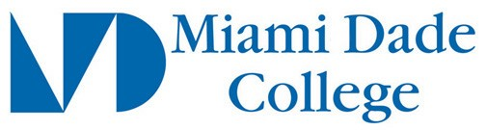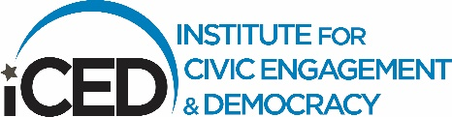

**MDC iCED Service Partner Parameters**

What is an iCED-Approved Service Partner?

**Service partner**: an organization that engages with iCED/MDC through its service pathways.

Service Partner Parameters:

* A 501(c)3 organization
* A nonprofit organization
* A pro-bono initiative or program from a for-profit organization
* A campus-based service provider (Single Stop, ACCESS, Food Pantry, etc.)
* A public sector agency such as a school, government office, or parks and recreation
* A community-led initiative such as a grassroots organization, coalition, or community group working to meet a clearly identifiable community need

iCED partners provide high-quality current service opportunities.

1. Vetted partner:
   1. Aligned with Service Partner Parameters
   2. Aligned with [Standards for Service](https://www.mdc.edu/iced/docs/standardsforservice.pdf)
   3. The service site partner has had a conversation with an iCED team member, understands the Standards for Service, and how it aligns with their service opportunities
   4. The iCED team member and the service site partner have determined how to support each other through a collaborative and mutually beneficial partnership
2. Quality partnerships:
   1. The service partner is responsive to iCED and MDC students
   2. The service partner clearly addresses a community need
   3. The service partner has clearly defined service opportunities
   4. The service partner has a process/procedure in place to receive volunteers
   5. iCED communicates regularly with partner and commits to listen and do our best to create and maintain a mutually beneficial/reciprocal partnership
3. Current:
   1. The service partner must be actively accepting new volunteers.

Ready to proceed? Continue with the Steps in the **How to Get Started** list [here](https://www.mdc.edu/iced/community-partners/default.aspx).

Questions? [Contact the iCED staff member](https://www.mdc.edu/iced/contact/default.aspx)at the campus closest to your service area.